Our Sunday Visitor Respect Life January 15, 2012

Couple counsels hurting mothers
Post-abortive women can find healing from anger, depression by sharing stories
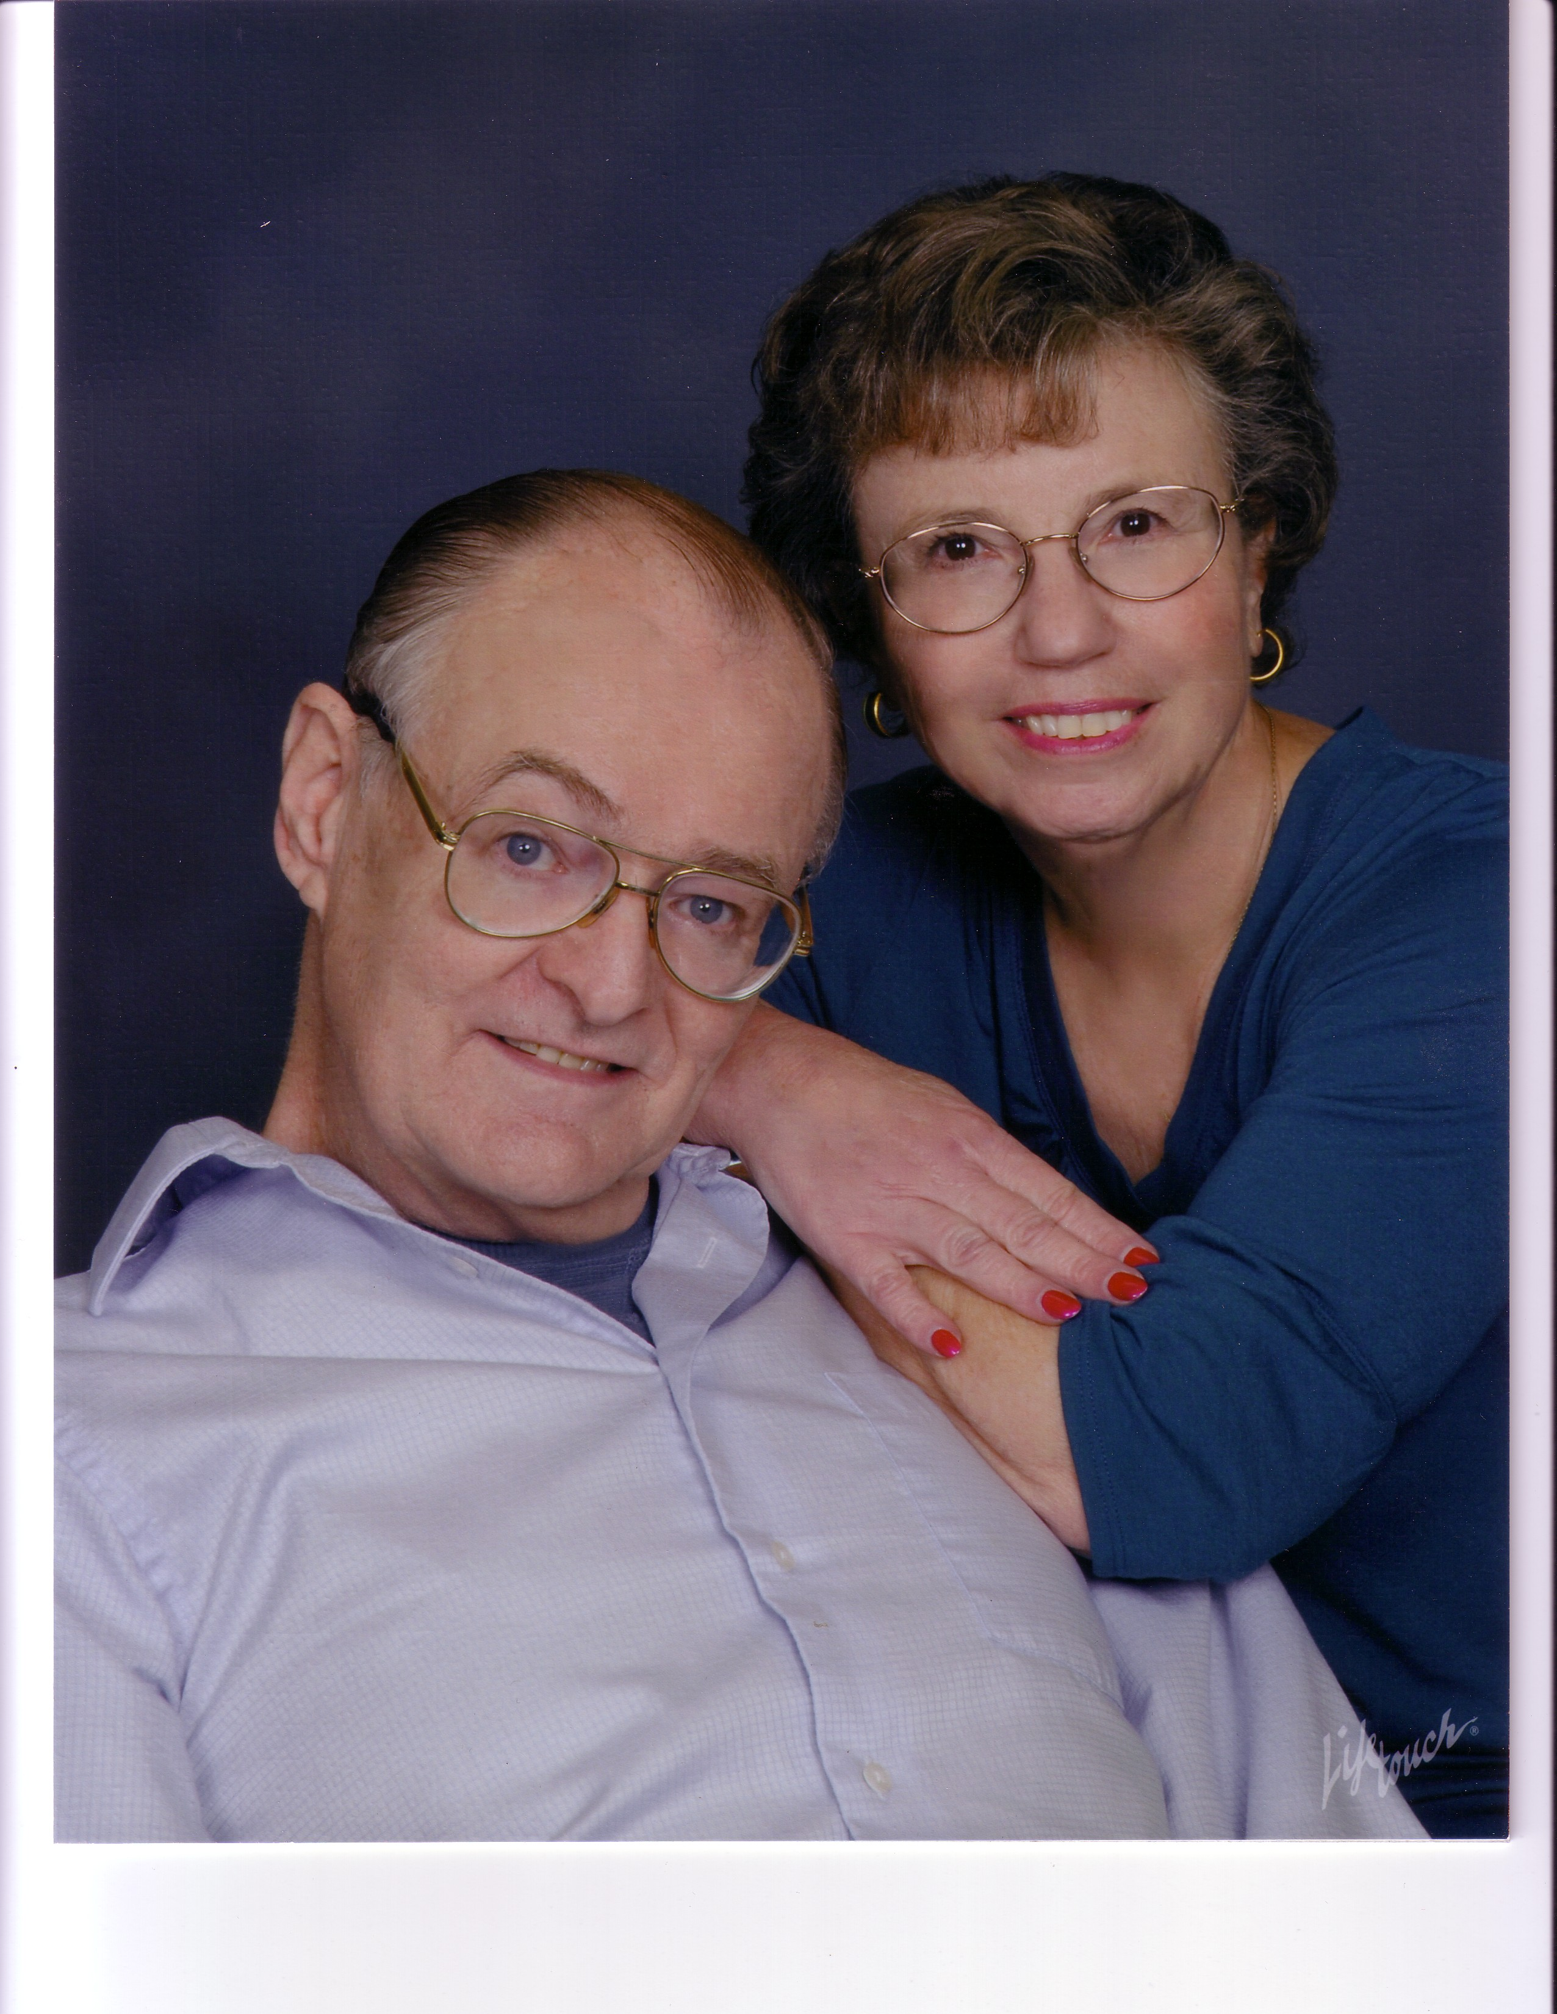
By Maryann Gogniat Eidemiller

In his private practice as a family therapist, Jim Benefield has counseled clients who eventually uncovered the grief and guilt of abortion as one of their underlying issues.
As a nurse at a crisis pregnancy center, his wife Rosemary encountered hurting women who were already post-abortive and didn’t want to have another.
In 1994 there were no Catholic services for post-abortive women and men in the Diocese of San Diego, Calif., so the couple wrote the program for Rachel’s Hope After Abortion Healing and initially ran it through Catholic Charities. It is now an independent program endorsed by the diocese.

So far, almost 700 women have gone through the interactive retreats that also have Spanish versions. Until declining health, Jim ran retreats for men.
Facing the grief
The Benefield’s have similar backgrounds in psychology and counseling and are committed to use those gifts to help people recover from abortion.
“For a woman, the memories of an abortion are like a photograph frozen in time,” Jim said. “Unless it is faced head on and dealt with courageously, there can be all sorts of issues with partner—difficulties, mistrusts, and she may unconsciously seek partners who are beneath her—one who will treat her badly because she says she deserves it.”
Although Jim routinely asks about “lost pregnancies” in taking client histories, some clients “will repress it so much” that they aren’t able to face their pain until later in the therapeutic process.
“Many therapists will address just the grief and loss part of it, but there’s so much more,” he said. “There’s shame and there’s guilt, and I am referring to existential guilt, not a neurotic guilt. You have to introduce the spiritual element because their pain is a soul wound and can be healed only by their relationship with God.”

Reconnecting with faith
Women and men often have turned away from their faith long before they were ready to heal. So as therapy progresses, Jim recommends that they seek the Sacrament of Reconciliation if they are Catholic, and or the weekend retreats.
“Many women come hopeful but fearful,” Rosemary said. “But once they have a chance to share their stories, they can begin to forgive themselves and be freed from depression, and be healed from anger if they felt coerced by the baby’s father or their parents. Even if their parents didn’t know, they felt like they couldn’t go to them for help.”
The retreats give the women a new support system and friendship, she added. “It becomes a sisterhood.”

