The Southern Cross March 26, 1998

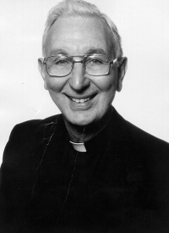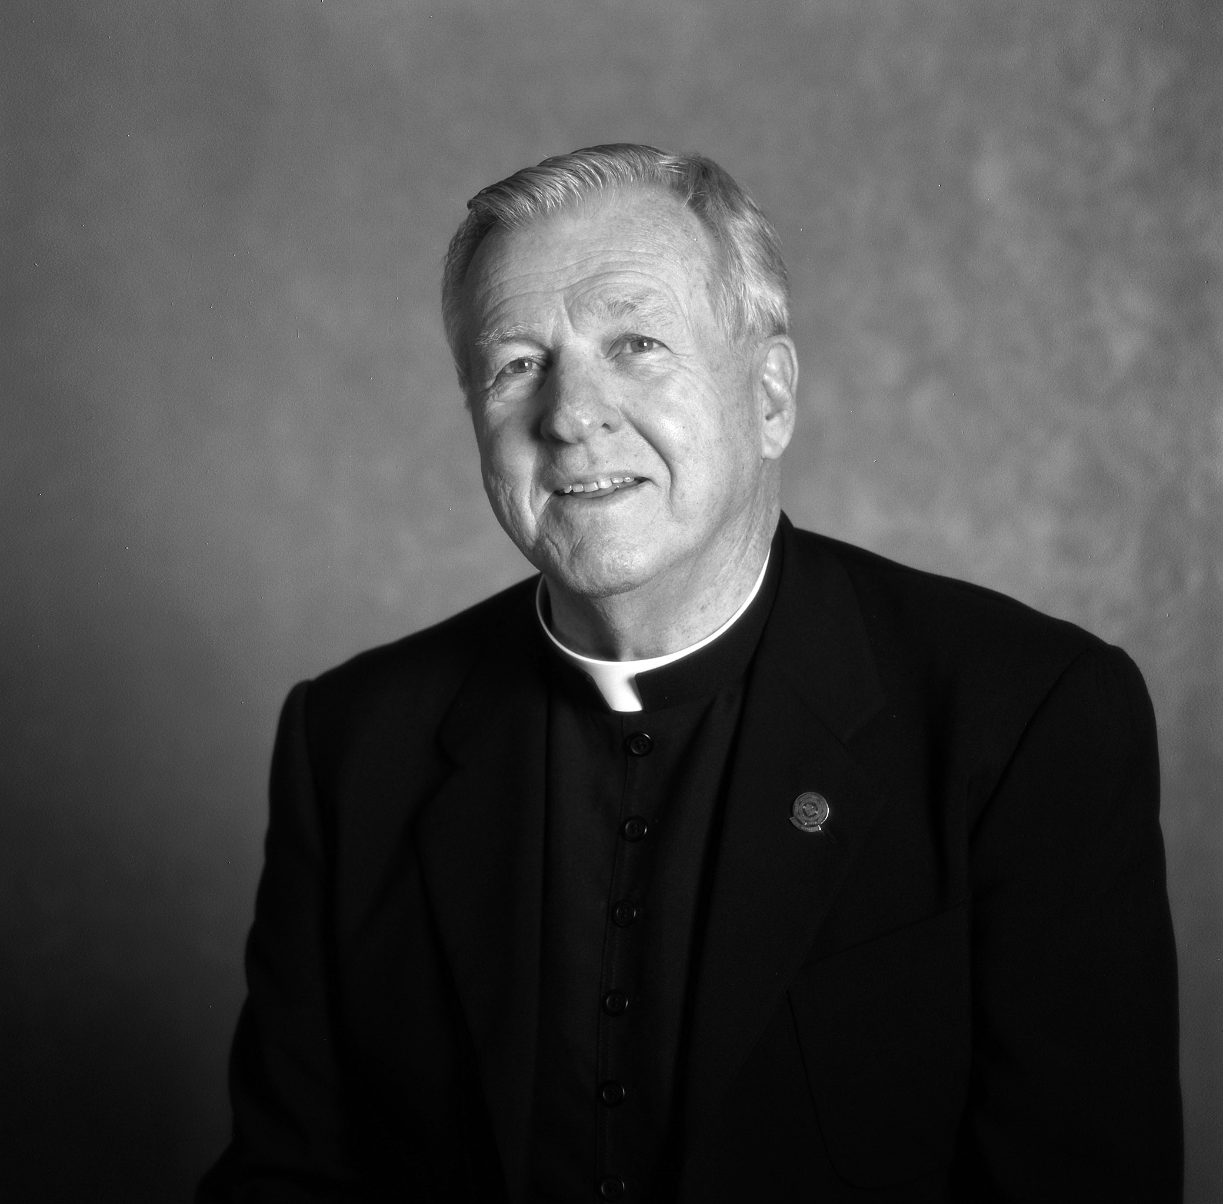
Fr. Lou Fisher Fr. Patrick Waite

Healing, Reconciliation for Abortion’s Other Victims (A Priest’s perspective)

By Kim Camplisson

The Southern Cross
San Diego – “At 6 O’clock one bitter cold morning, 20 years ago when I was a pastor in Salt Lake City, a young woman rang my doorbell,” remembered Father Louis Fischer, a retired hospital chaplain. “Mascara was running down her face from her tears. It was the 10th anniversary of her abortion, and she told me that on all 10 anniversaries she had considered suicide. It broke my heart.”
` Seeing firsthand how “devastating abortion is to the human spirit” led Father Fischer to reach out to women despairing over a past abortion. His empathy for these grieving women has led him to Rachel’s Hope, a healing ministry for women who are grieving over past abortions. Along with Father Pat Waite, a retired naval chaplain, he celebrates Mass at the end of the Rachel’s Hope weekends after hearing the women’s confessions.
The weekends, run by Rosemary Benefield, an RN with a Masters in Marriage and Family Counseling and Pastoral Counseling, average 10 women. “A larger group couldn’t achieve the same healing,” said Father Waite. “By the time we come to hear confessions,” he continued, “the women have already released a lot of their grief and anger. I wish everybody who used the sacrament of reconciliation was as well-prepared.”
Many of the women have received sacramental reconciliation in the past, but are still burdened by guilt, said Father Fischer. “You can have all the sacramental absolution in the world, but unless you are open to the Good News, it is difficult to forgive yourself.”
Father Waite concurs. Due to fear and shame, many women confessed their abortions anonymously, in circumstances which did not give their confessors adequate time to counsel and console them. He finds the Rachel’s Hope experience satisfying because it gives him the chance to “really be a practitioner of the art of father confessor.”
The weekend experience allows the priest to “bring the compassion and healing of Jesus” to the women, explained Father Fischer, to bring “healing, understanding and acceptance” in a way that might not have been as evident in an anonymous confession. The weekend seminar lets them work through their pain with others who are in similar situations.
While the priests do not participate in the workshops, they do get a chance to meet the women and help them feel at ease before confession. “I tell them that the earliest Christians called confession a second baptism, and that now they’ll be restored to baptismal purity,” said Father Waite. But, unlike their baptisms as infants, “this time they came on their own, they weren’t carried to this baptism,” he said.
“I tell them how wonderful it is to have them back,” said Father Fischer. Both priests strive to help restore a sense of self-worth to the women.
“Rosemary really does a good job of loving these women,” remarked Father Fischer.
Some of the women who have participated in Rachel’s Hope volunteer to visit deanery meetings to share their experience with pastors. “This helps (priests) if they haven’t had the opportunity, besides the occasional encounter in the confessional, to hear a personal story of how (the abortion) transpired.”
While the guilt the women feel doesn’t magically disappear after the healing weekend, Father Fischer says the Rachel’s Hope experience reminds the women that “the Lord does tenderly and lovingly care for them.”

